Java Packages
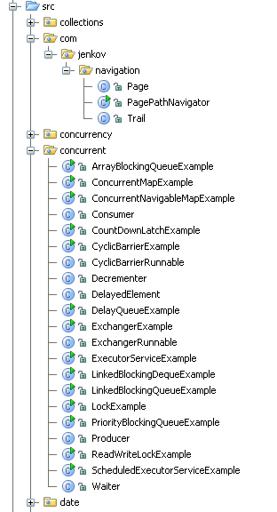
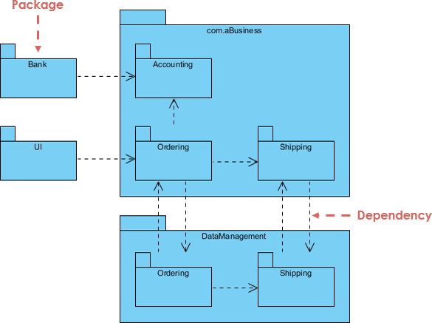
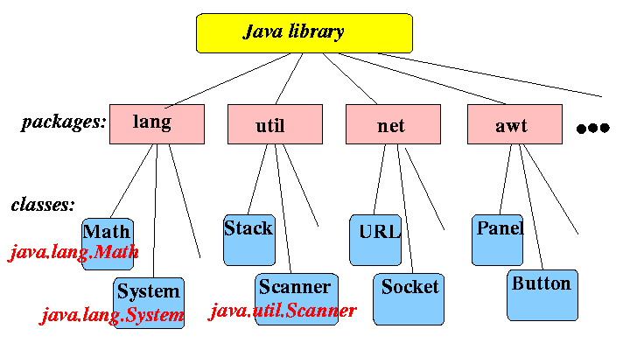
A package in Java is a namespace that groups related classes, interfaces, and sub-packages. It helps in organization, access control, and avoiding name conflicts.

✅ 1) Why Packages? (Core Rationale)
Java packages provide:
Benefit | Explanation
Organization | Groups related classes (e.g., java.util, java.io)
Name Conflict Avoidance | Two classes can have the same name in different packages
Access Control | Works with public, protected, default, private
Reusability & Maintenance | Easier to manage large projects

✅ 2) Types of Packages

A) Built-in (Standard) Packages
Provided by Java API.
Examples:
java.lang // Default imported
java.util // Collections, Scanner
java.io // Input/Output
java.sql // Database
Example usage:
import java.util.Scanner;

Scanner sc = new Scanner(System.in);

B) User-Defined Packages

Step 1 — Create a package
File: Calculator.java
package mypack;

public class Calculator {
public void add(int a, int b) {
System.out.println(a + b);
}
}
Rule: The package statement must be the first statement (excluding comments).

Step 2 — Compile with package
javac -d . Calculator.java
This creates a folder:
mypack/
Calculator.class

Step 3 — Use the package in another class
File: Main.java
import mypack.Calculator;

public class Main {
public static void main(String[] args) {
Calculator c = new Calculator();
c.add(5, 10);
}
}
Compile & run:
javac Main.java
java Main

✅ 3) Ways to Import a Package

(a) Single Class Import
import mypack.Calculator;

(b) Wildcard Import (All classes)
import mypack.*;
Note: * imports only classes in that package, not sub-packages.

✅ 4) Default Package (When no package is declared)
public class Test {
void show() {
System.out.println("Default package");
}
}
⚠️ Limitation:
- Classes in the default package cannot be imported into classes in named packages.

✅ 5) Access Modifiers & Packages (Critical)
Modifier | Same Class | Same Package | Subclass (Diff Package) | Anywhere
private | ✅ | ❌ | ❌ | ❌
default | ✅ | ✅ | ❌ | ❌
protected | ✅ | ✅ | ✅ | ❌
public | ✅ | ✅ | ✅ | ✅

Example: protected across packages
package1/A.java
package package1;

public class A {
protected void show() {
System.out.println("Hello");
}
}
package2/B.java
package package2;
import package1.A;

class B extends A {
public static void main(String[] args) {
B obj = new B();
obj.show(); // Allowed
}
}

✅ 6) Nested (Sub) Packages
Structure:
com/
company/
project/
service/
Declare as:
package com.company.project.service;
Import:
import com.company.project.service.*;

✅ 7) Common Interview Traps

Trap 1 — Order of statements
// ❌ WRONG
import java.util.Scanner;
package mypack;

// ✅ CORRECT
package mypack;
import java.util.Scanner;

Trap 2 — Default package import
Classes in default package cannot be imported into named packages.

Trap 3 — Wildcard does NOT import sub-packages
import com.company.*; // ❌ Does NOT import com.company.service

✅ 8) Real-World Best Practice (Recommended Structure)
src/
├── com/
│ └── company/
│ └── app/
│ ├── model/
│ ├── service/
│ └── util/
Example:
package com.company.app.model;

public class User { }

